Adaptive Head Lamps Control Function – CGEA1.3

Functional Description

This STSS handles the Adaptive Head Lamps feature, which provides customers the choice to activate or deactivate the use of Adaptive Head Lamps and to select the side of the road traffic will drive on via the settings menu. The Instrument Cluster uses the Personalization signals for the Message Center function to set to enable or disable the Adaptive Head Lamps feature in the HCM module as well as selecting RHD or LHD.

Starting in MY2019 with U625/U611 the Settings are migrating from the cluster to Center stack. This STSS supports displaying settings in the cluster or configuring the cluster settings off if they are displayed in the Center stack.

The customer uses the message center switches and display to enable and/or change the Adaptive Head Lamps settings in the vehicle.

Interfaces

Interface Context Diagram (I/O Block Diagram)
Figure 1 Adaptive Head Lamps Function Context Diagram
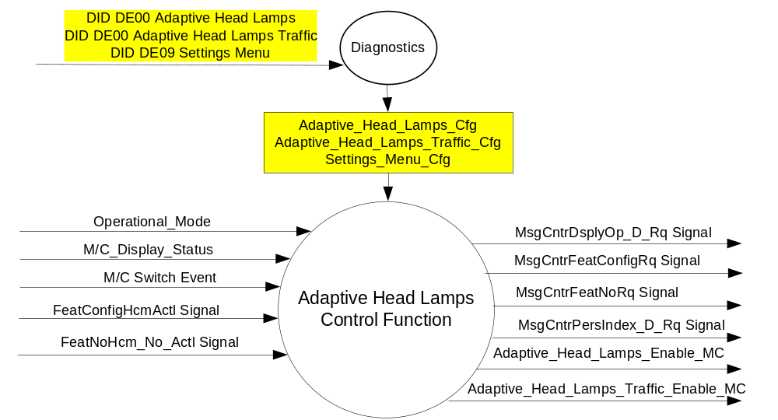

Inputs

- INTERNAL:
- Operational_Mode
- M/C Switch Event
- Adaptive_Head_Lamps_Cfg
- Adaptive_Head_Lamps_Traffic_Cfg
- Settings_Menu_Cfg
- M/C_Display_Status
- MUX message on the CAN Bus

- FeatConfigHcmActl Signal
Signal Name | Size (bits) | Detail | Units | Res. | Offset | State Encoded | Min | Max
FeatConfigHcmActl | 16 | - | Undefined | 1 | 0 |  | 0  (0x0) | 65535  (0xFFFF)
- FeatNoHcm_No_Actl Signal
Signal Name | Size (bits) | Detail | Units | Res. | Offset | State Encoded | Min | Max
FeatNoHcm_No_Actl | 16 | - | Number | 1 | 0 |  | 0  (0x0) | 65535  (0xFFFF)
Note: HCM does not have a PersIndexHcm_D_Actl signal.

Outputs
- Adaptive_Head_Lamps_Enable_MC
- MUX message on the CAN Bus

- MsgCntrDsplyOp_D_Rq Signal
Signal Name | Size (bits) | Detail | Units | Res. | Offset | State Encoded | Min | Max
MsgCntrDsplyOp_D_Rq | 3 |  | SED | 1 | 0 |  | 0  (0x0) | 7  (0x7)
 |  | NULL |  |  |  | 0 (0x0)
 |  | QUERY |  |  |  | 1 (0x1)
 |  | SET |  |  |  | 2 (0x2)
 |  | UPLOAD |  |  |  | 3 (0x3)
 |  | RESTORE |  |  |  | 4 (0x4)
 |  | COPY |  |  |  | 5(0x5)
 |  | Not used |  |  |  | 6 (0x6)
 |  | Not Used |  |  |  | 7 (0x7)
.
- MsgCntrFeatConfigRq Signal
Signal Name | Size (bits) | Detail | Units | Res. | Offset | State Encoded | Min | Max
MsgCntrFeatConfigRq | 16 |  | Undefined | 1 | 0 |  | 0  (0x0) | 65535  (0xFFFF)

- MsgCntrFeatNoRq Signal
Signal Name | Size (bits) | Detail | Units | Res. | Offset | State Encoded | Min | Max
MsgCntrFeatNoRq | 16 |  | Number | 1 | 0 |  | 0  (0x0) | 65535  (0xFFFF)

- MsgCntrPersIndex_D_Rq
Signal Name | Size (bits) | Detail | Units | Res. | Offset | State Encoded | Min | Max
MsgCntrPersIndex_D_Rq | 3 |  | SED | 1 | 0 |  | 0  (0x0) | 7  (0x7)
 |  | PERS_1 |  |  |  | 0 (0x0)
 |  | PERS_2 |  |  |  | 1 (0x1)
 |  | PERS_3 |  |  |  | 2 (0x2)
 |  | PERS_4 |  |  |  | 3 (0x3)
 |  | Vehicle |  |  |  | 4 (0x4)
 |  | Not Used |  |  |  | 5 (0x5)
 |  | Not Used |  |  |  | 6 (0x6)
 |  | Not Used |  |  |  | 7 (0x7)

Function/Performance

Operational Modes

Mode | Differentiating Vehicle Conditions
Sleep Mode | Adaptive Head Lamps Control Function Text Messages Disabled
Limiting Mode | Adaptive Head Lamps Control Function Text Messages Disabled
Normal Mode | Adaptive Head Lamps Control Function Text Messages Enabled / Disabled
Crank Mode | Adaptive Head Lamps Control Function Text Message Enabled / Disabled

Voltage Levels

Refer to the Cluster Features table located in the Operational Modes and Voltage Range Strategies Section in this SPSS.

Human-Machine Interface

Visual

Indicator Graphics / Display Format
For program specific display, refer to “<Program> Cluster Menu Structure.xls” and Program VAPS Model.
Example Graphics (with just Adaptive Headlamps DE00 configured on):
Level 2 | Level 3 | Level 4 | Level 5
Lighting > | Adaptive Head Lamps > | # Adaptive Head Lamps

Example Graphics (with both Adaptive Headlamps and Adaptive Headlamps Traffic configured on):
Level 2 | Level 3 | Level 4 | Level 5
Lighting > | Adaptive Head Lamps > | # Adaptive Head Lamps
 |  | Traffic Set Up > | * Right Hand Traffic
 |  |  | * Left Hand Traffic

Indicator Color Coordinates

Reference section COLOR & ILLUMINATION REQUIREMENTS (GRAPHICS)

Indicator Characteristics

Refer to Message Center X Display_Y Button Interface Section, where X and Y are appropriate values in this document.

Audio

None

Switch Control Logic

Consumer access to the Adaptive Head Lamps Control Configuration shall be as specified in the message center basic functionality display as specified in Message Center X Display_Y Button Interface Section, where X and Y are appropriate values in this document.

System Accuracy

Within a 100msec of receiving a message that results in a change of state the cluster will update the display to the proper status.

Operation: Performance and Functional

Subsystem Algorithm Flowchart / State Diagram

Figure 2 Adaptive Head Lamps Diagnostic Flowcharts
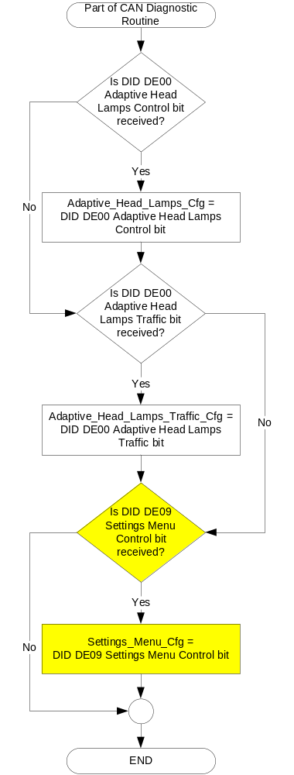

Figure 3: Adaptive Head Lamps input SET request Flowcharts

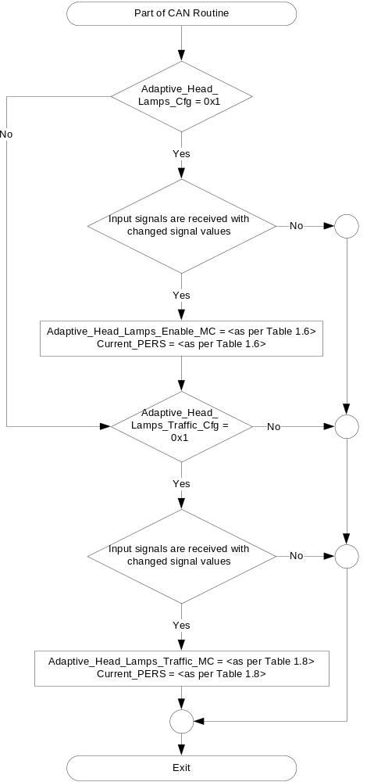

Figure 4: Adaptive Head Lamps output SET request Flowcharts

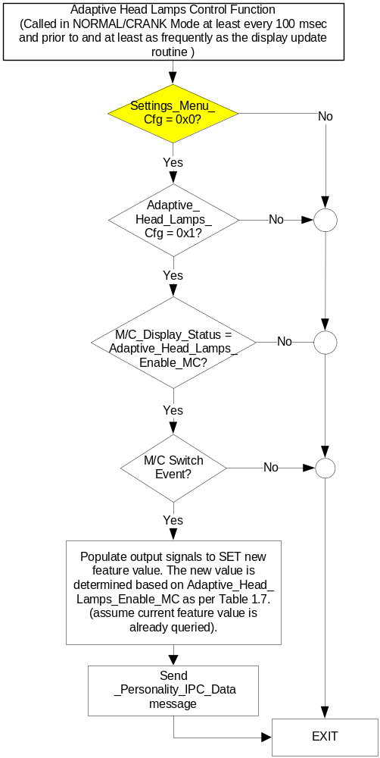

NOTE: In the Adaptive Head Lamps Control Function Flowchart, the definition of "M/C Switch Event" is defined in Message Center X Display_Y Button Interface Section, where X and Y are appropriate values in this document.

Figure 5: Adaptive Head Lamps Traffic output SET request Flowcharts

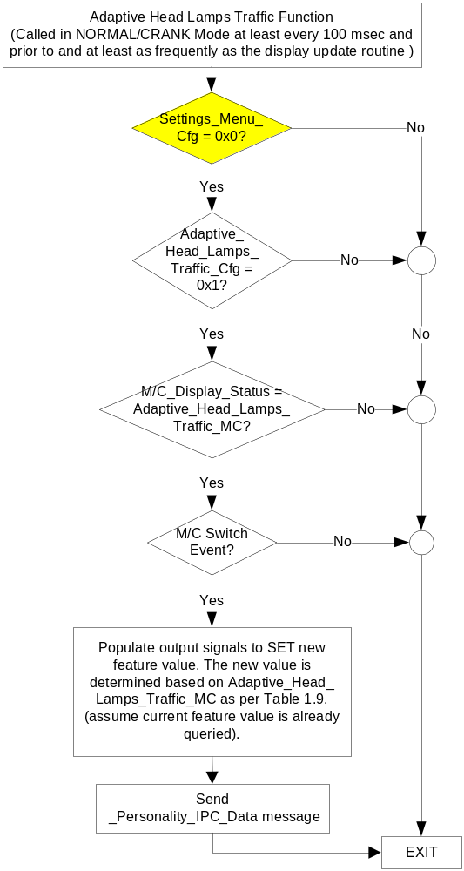

NOTE: In the Adaptive Head Lamps Traffic Flowchart, the definition of "M/C Switch Event" is defined in Message Center X Display_Y Button Interface Section, where X and Y are appropriate values in this document.

Operation Description (supports algorithm flowchart /state diagram)

- Adaptive_Head_Lamps_Enable_MC State Assignment
FeatNoHcm_No_Actl | FeatConfigHcmActl | Adaptive_Head_Lamps_Enable_MC | Current_PERS ⁽³⁾
0x040E ⁽¹⁾ | Disable  (0x00) | Disable  (0x0) | 0x4
0x040E ⁽¹⁾ | Enable  (0x01) | Enable  (0x1) | 0x4
0x040E ⁽¹⁾ | Other ⁽²⁾ | Error  (0x2) | Last Known
Missing per Section 1.4.1 ⁽²⁾ |  | Error  (0x2) | Last Known
⁽¹⁾ Adaptive Head Lamps Enable Feature Number. Reference is Feat Num table in “Vehicle Personalization FS”
⁽²⁾ Message Response is Faulted
⁽³⁾ HCM does not have a PersIndexHcm_D_Actl signal, otherwise Current_PERS would be set equal to the received “PersIndex<--->” signal value and when faulted Keep last known value.

- Message Center Display and MC Adaptive Head Lamps Request Messages

based upon Adaptive_Head_Lamps_Enable_MC
Adaptive_  Head_Lamps_Enable_MC | Display Menu | 5-Button Switch Selection Event | MsgCntrDsplyOp_D_Rq  Signal | MsgCntrFeatNoRq  Signal | MsgCntrFeatConfigRq  Signal | MsgCntrPersIndex_D_Rq  Signal
Off  (0x0) |  Off   On | Up/Down + OK (Select On) | SET (0x2) | 0x040E | 0x01 (Enabled) | Current_PERS
On  (0x1) |  Off   On | Up/Down + OK (Select Off) | SET (0x2) | 0x040E | 0x00 (Disabled) | Current_PERS
Error  (0x2) |  Off   On | Up/Down + OK (Select Off or On) | SET (0x2) | 0x040E | 0x00 (if Off is selected)  0x01 (if On is selected) | Current_PERS

- Adaptive_Head_Lamps_Traffic_MC State Assignment
FeatNoHcm_No_Actl | FeatConfigHcmActl | Adaptive_Head_Lamps_  Traffic_MC | Current_PERS ⁽³⁾
0x040F ⁽¹⁾ | LHT  (0x00) | LHT  (0x0) | 0x4
0x040F ⁽¹⁾ | RHT  (0x01) | RHT  (0x1) | 0x4
0x040F ⁽¹⁾ | Other ⁽²⁾ | Error  (0x2) | Last Known
Missing per Section 1.4.1 ⁽²⁾ |  | Error  (0x2) | Last Known
⁽¹⁾ Adaptive Head Lamps Traffic Feature Number. Reference is Feat Num table in “Vehicle Personalization FS”
⁽²⁾ Message Response is Faulted
⁽³⁾ HCM does not have a PersIndexHcm_D_Actl signal, otherwise Current_PERS would be set equal to the received “PersIndex<--->” signal value and when faulted Keep last known value.

- Message Center Display and MC Adaptive Head Lamps Request Messages

based upon Adaptive_Head_Lamps_Traffic_MC
Adaptive_  Head_Lamps_Traffic_MC | Display Menu | 5-Button Switch Selection Event | MsgCntrDsplyOp_D_Rq  Signal | MsgCntrFeatNoRq  Signal | MsgCntrFeatConfigRq  Signal | MsgCntrPersIndex_D_Rq  Signal
LHD  (0x0) |  LHT   RHT | Up/Down + OK (Select RHD) | SET (0x2) | 0x040F | 0x01 (RHT) | Current_PERS
RHD  (0x1) |  LHT   RHT | Up/Down + OK (Select LHD) | SET (0x2) | 0x040F | 0x00 (LHT) | Current_PERS
Error  (0x2) |  LHT   RHT | Up/Down + OK (Select LHD or RHD) | SET (0x2) | 0x040F | 0x00 (if LHT is selected)  0x01 (if RHT is selected) | Current_PERS

- Personalization Features for Adaptive Head Lamps
Feature Name | Feature Num | Cfg Num | Cfg Value
Adaptive Head Lamps | 0x040E | 0x01 | Enable
Adaptive Head Lamps | 0x040E | 0x00 | Disabled
Adaptive Head Lamps RHT/LHT | 0x040F | 0x01 | RHT (Right Hand Traffic)
Adaptive Head Lamps RHT/LHT | 0x040F | 0x00 | LHT (Left Hand Traffic)

Function Safety Classification (EMC)

Class B

Memory Storage

Parameter Name | Description | Value at  Battery Connect | Value at  Module Wake-up
Adaptive_Head_Lamps_Enable_MC | Output displayed in the M/C | Disabled (0x0) | Do Not Init
Adaptive_Head_Lamps_Traffic_MC | Output displayed in the M/C | LHD (0x0) | Do Not Init
MsgCntrDsplyOp_D_Rq Signal | Output Signal to indicate Request Type. | NULL (0x0) | Do Not Init
MsgCntrFeatNoRq Signal | Output Signal to indicate Feature Number. | (0x0000) | Do Not Init
MsgCntrFeatConfigRq Signal | Output Signal to Specify the desired feature Value. | (0x0000) | Do Not Init
MsgCntrPersIndex_D_Rq Signal | Output Signal to indicate which personality profile is being accessed. | Vehicle (0x4) | Do Not Init
FeatNoHcm_No_Actl Signal | Input signal sent from HCM to indicate Feature Number. | (0x0000) | Do Not Init
FeatConfigHcmActl Signal | Input signal sent from HCM to indicate current value of the feature setting for the feature that is being set or queried. | (0x0000) | Do Not Init
Adaptive_Head_Lamps_Cfg | Configures cluster to allow Adaptive Head Lamps. Set to Disabled at Cluster Supplier Manufacturing Plant. | Use Stored Value | Use Stored Value
Adaptive_Head_Lamps_Traffic_Cfg | Configures cluster to allow Adaptive Head Lamps Traffic selection. Set to LHD at Cluster Supplier Manufacturing Plant. | Use Stored Value | Use Stored Value
Settings_Menu_Cfg | Configures cluster to display items in the Settings menu (Set to “cluster” at cluster supplier manufacturer plant) | Use Stored Value | Use Stored Value
M/C_Display_Status | State Indicator to identify which text is currently being displayed on Message Center display. See * | See * below | See * below
M/C Switch Event | Event that is indicated as per the switch interface for the Message Center. See * | See * below | See * below
Operational_Mode | 4 state indicator for cluster operational mode | Limited | Limited, Normal or Crank

* Refer to Message Center X Display_Y Button Interface Section, where X and Y are appropriate values in this document.

Reconfigurable Telltale

Not Applicable

Prove Out

Not applicable

Message Center Msg

None

Error Handling

Missing Message Strategy

The signals will be declared missing as per the Diagnostics section of this SPSS.

DTCs states and history will be determined as per the Diagnostics section of this SPSS.

If Adaptive_Head_Lamps_Cfg = Disabled, the cluster shall never log a missing message for this feature.

Diagnostics

Self Test

None

Engineering Test Mode

Reference section “Dealer / Engineering Test Mode (ETM)”

Part II Performance

Supported Diagnostic Trouble Codes (DTCs)
DTC | Description
C24100 | Lost Communication With Headlamp Control Module "A"

DID DExx:
Block  Num | Block Description | Size (bits) | Byte(s) | Bits | State: Description | "0" | "1" | Default | Comments/Information
PACKETED BLOCKS
$00 | Option Content (B&A) | * | * | * | Adaptive Head Lamps Control Function | Disabled | Enabled | Disabled | Disabled means the Adaptive Headlamps On/Off menu is not displayed in the cluster. At this time, this bit should be ALWAYS DISABLED.
$00 | Option Content (B&A) | * | * | * | Adaptive Head Lamps Traffic | Disabled | Enabled | Disabled | Disabled means the Adaptive Headlamps Right Hand Traffic/Left Hand Traffic menu is not displayed in the cluster. When Enabled, this allows the driver to use the cluster to select on which side of the road traffic is driving. This is necessary in FoE where traffic will drive on different sides of the road from country to country. It can be over-ridden by the Settings Menu config.
$09 | Option Content (B&A) | * | * | * | Settings Menu | Cluster | Center Stack | Cluster | This parameter allows the Settings menu to be displayed in the cluster when 0x0. When 0x1, the expectation is that settings are displayed in the Centerstack. For this feature (when 0x1), the cluster will remove almost all items from settings menu. (Cluster display choices remain). Note this is a global config, each feature still has its own config for presence on vehicle.
 | *Byte and bit location to be identified in Part II Specification for this cluster

Reference Specification

None.

Revision History
SPSS Module Revision History
Revision Level | Name | Change Description | Date
1.0 | J. Gregoire | Initial Release | 12/9/2010
2.0 | J. Gregoire | Per HMI simplification effort, Adaptive Head Lamp menu has changed from Off, Sport, Comfort to Off/On. Also, new HMI added for RHD/LHD traffic selection. To implement this, Personalization Feature Number 0x040E has been redefined and a new Feature Number 0x040F has been defined for RHD/LHD. Also added new DE00 config for traffic detection menu (RHD/LHD).  Section 1.1 – Updated settings to On/Off and added RHD/LHD.  Figure 1.1 – Added Adaptive_Head_Lamps_Traffic_Cfg  Section 1.2.2 – Added Adaptive_Head_Lamps_Traffic_Cfg  Section 1.3.3.2 – Updated Example Graphics settings to On/Off and added RHD/LHD.  Figure 2 Part of CAN Diagnostic Routine Flowchart.– Added Adaptive_Head_Lamps_Traffic_Cfg.  Figure 2 Part of CAN Routine Flowchart.– Added setting Adaptive_Head_Lamps_Traffic_MC.  Figure 2 Adaptive Head Lamps Traffic Function – All new.  Table 1.6 – Updated settings to On/Off.  Table 1.7 – Updated settings to On/Off.  Table 1.8 – All new, added for setting RHD/LHD.  Table 1.9 – All new, added for setting RHD/LHD.  Table 1.10 – Updated settings to On/Off and added RHD/LHD  Section 1.3.5.4 – Updated Adaptive_Head_Lamps_Enable_MC, Added Adaptive_Head_Lamps_Traffic_MC and Adaptive_Head_Lamps_Traffic_Cfg  Section 1.5.3 – Added Adaptive_Head_Lamps_Traffic_Cfg. | 2/13/2012
3.0 | S. Watkins | The 2 menus are independent of each other. In other words, the expected case is to have Adaptive_Head_Lamps_Traffic_Cfg Enabled, but have Adaptive_Head_Lamps_Cfg Disabled. This is because the primary direction is to only offer the customer the choice of RH Traffice vs LH Traffic in Europe.  - Section 1.3.5.1 – Part of CAN Routine flowchart. Changed “No” path from 1st decision diamond.  - Changed “Normal” to “Normal/Crank” in all the flowcharts.  - Changed “DE00” to “DExx” throughout. | 3/28/2014
3.1 | S. Watkins | There was some confusion because the HMI text refers to “Right Hand Traffic” and the feature number 0x040F refers to Right Hand Drive. Technically, they are opposites. Thus, it was decided to re-define feature 0x040F as “Right Hand Traffic”. This would match the HMI description to the feature number.  - Change “RHD” to “RHT” and change “LHD” to “LHT” in Table 1.8, Table 1.9, Table 1.10. | 7/8/2014
4.0 | S. Watkins | Starting in MY2019 with U625/U611 the Settings are migrating from the cluster to Centerstack. This STSS update is to support this effort. A configuration is added to ensure backward compatiblity.  Changes shown in yellow:  - Section 1.1 – Updated description to mention Center Stack  - Section 1.2.1, Figure 1 – Added DE09 Settings Menu  - Section 1.2.2 – Added Settings_Menu_Cfg  - Section 1.3.5.1, Figure 2 – Added DE09 Settings Menu  - Section 1.3.5.1, Figure 4 and Figure 5 – Added decision box for Settings_Menu_Cfg.  - Section 1.3.5.4 – Added Settings_Menu_Cfg  - Section 1.5.3 – Added Settings Menu to DE09 | 1/6/2017

